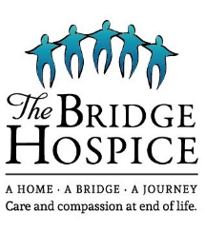
SKATE-A-THON PLEDGE FORM – Saturday, December 30, 2023 ~ 2 – 3:30 pm

___________________________________________________________________________________________
Participant First & Last Name (please print) EMAIL ADDRESS Mobile Number

_______________________________________________________________________________________________________________________________________________________________
MAILING ADDRESS – please include post office box number (if relevant) and postal code

PLEDGER First & Last Name | ADDRESS  (include P.O. box, civic address, RR # & postal code) | Phone | Pledge/Lap | Flat Donation | Total Collected
Please make cheques payable to: The Bridge Hospice Foundation ● Tax receipts issued for donations of $20 or more with complete contact information. Registered Charitable Org No. #747674331RR0001. |  |  | TOTAL:

Waiver / Release – please read carefully. In volunteering to participate in the 2023 Skate-a-thon in support of The Bridge Hospice, I hereby agree that this activity shall be of my own risk against all casualties to myself or my property. I take all risks of any kind no matter how caused, and hereby release and discharge The Bridge Hospice, sponsors, officials, organizers and any person involved in the Skate-a-thon and indemnify them of and from all actions, claims, demands of every nature and kind. I shall permit free use of my name and picture in publicity concerning the event. I am physically fit to participate in the event. I have read and fully understand and agree with the contents of this waiver/release prior to participation in the Skate-a-thon.
*I agree to receive occasional email from The Bridge Hospice.
DATE: _________________ SIGNATURE: _______________________________________________________ (You may withdraw consent at any time.)
day / month /year If participant is under 18, parent or guardian must sign.

